Dev - Content Aware Widget Arbitration - Engineering Diagrams

AI Engagement Prediction Model Flowchart
This flowchart illustrates the data pipeline for evaluating widget engagement likelihood:
- Triggered by lock/unlock events
- Ingests widget metadata (type, last use)
- Extracts user context (time of day, recent behavior)
- Scores the widget using a trained AI model
- Outputs a 0.0–1.0 engagement likelihood score
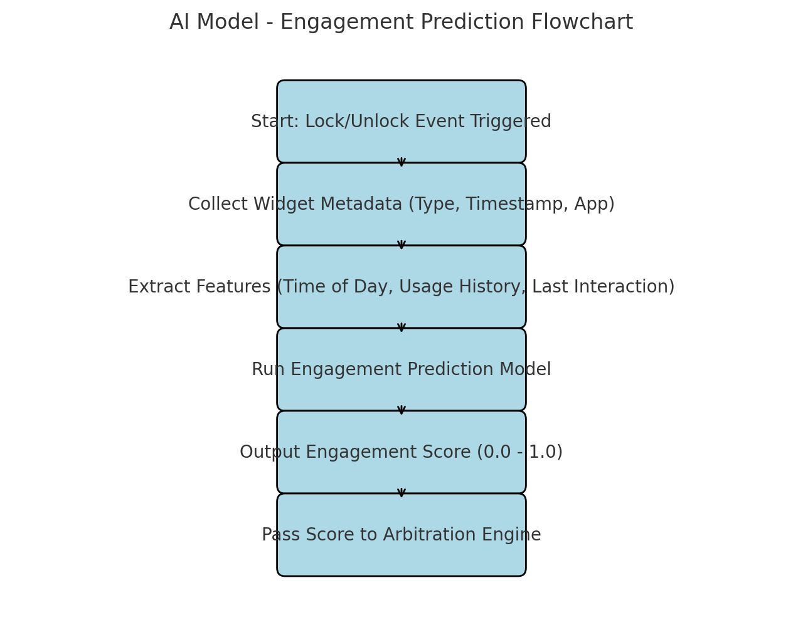

Widget Refresh Arbitration Decision Tree
This diagram outlines how the system decides whether to refresh or suppress widget updates:
- Takes the engagement score
- Compares against a threshold
- Checks override policies
- Final decision: Refresh or Suppress
- Decision is logged and executed
